# Lab 4.2 Modify the FAQs application

This exercise involves making a minor modification to the FAQs application shown in the notes. When you’re finished, this application should work the same as before, except that only one answer can be displayed at a time. In other words, when the user clicks on a heading to display the answer, the other answers must be hidden.

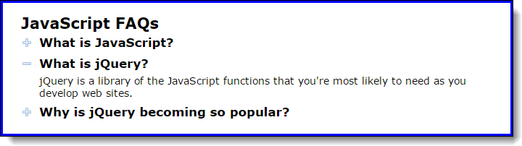

1. Open the HTML and JavaScript files in this folder:

\faqs\

Then, run the application to refresh your memory about how it works.

1. Enhance the code in the JavaScript file so only one answer can be displayed at a time.